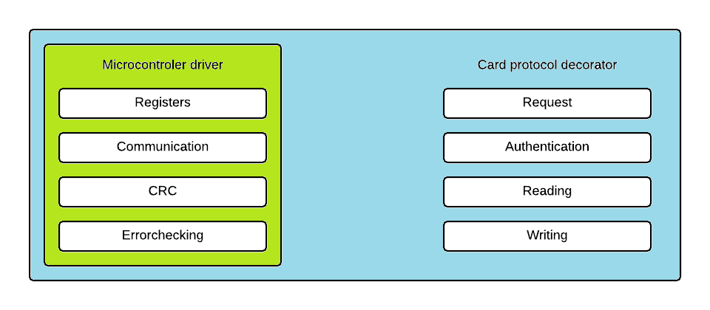Nfccontroller library

The Nfccontroller library that can be used to use an NFC microcontroller to communicate with NFC cards.

The library is split into two parts: The microcontroller driver and the Card protocol decorator.

Microcontroller driver.

The microcontroller side of the library focuses on the The Card protocol side of the library focuses

internal workings of a NFC oriented microcontroller. on card specific protocols and procedures.

It functions like a wrapper for the controller

The core functionality of the drive comes the Card protocol’s functionality has a

from manipulating the microcontroller’s more linear flow but is also a bit more

internal registers. These registers control abstract.

all the functions and settings of the The request sends a specific signal to a

microcontroller. From turning off the card which wakes the card up and allows

antenna to the sending and receiving of it to receive additional commands which

data. would otherwise be ignored.

The communication functionality Authentication is required for the actual

handles the successive manipulation of reading and writing of data. It usually

the registers that are needed to send and works via a series of challenges and

receive data. The actual data that is sent answers that functions as a handshaking

and the structure hereof is controlled by the protocol decorator. procedure that afterwards allows the microcontroller to manipulate the internal data of

The CRC (cyclic redundancy check) handles the procedure to check if the data that is sent or received card. This internal manipulation is done via the respective write and read protocols of the

is the correct data. It does this by processing the to be sent data and adding the result to of this process to card. The write and read protocols main function is to keep track of how data is stored on

the data that is to be sent. For incoming data it compares the received CRC answer to its own calculation. the card and how to handle this properly. All of these procedures can be found in the

Finally the error checking is handled by reading various internal registers of the microcontroller and respective documentations of that card. But for ease of use they have been included into

comparing them to preset results found in their respective documentation. If the result does not match the library.

what is expected and error signal is given.